Machine Learning & Stocks
Unsupervised Learning
Che 7700 – APC Project
Joshua Vaughn
Wenhao Chang
Ifeoluwakiitan Akinyem

Overview:

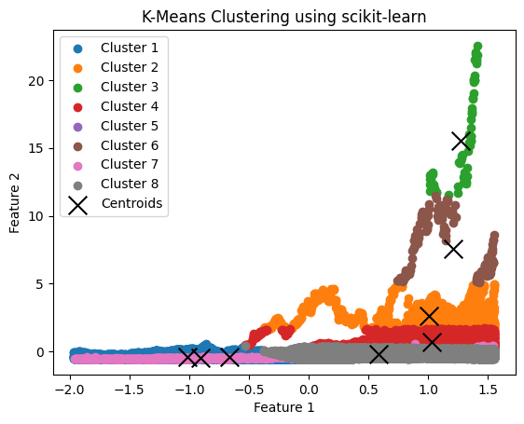 | 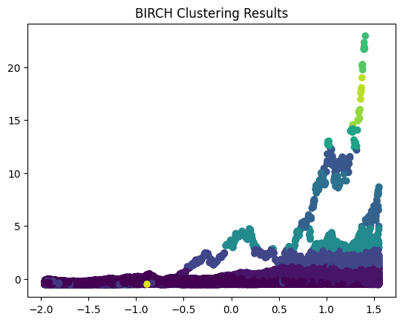 | 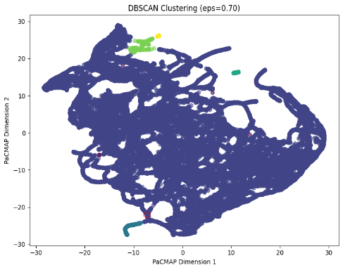
Figure 1: Clustering Methods (Right to left, K-Means, BIRCH, DBSCAN)
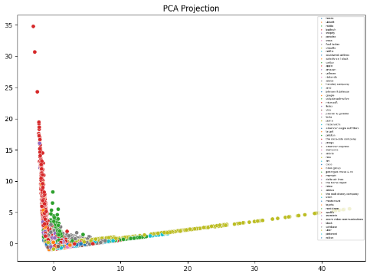 | 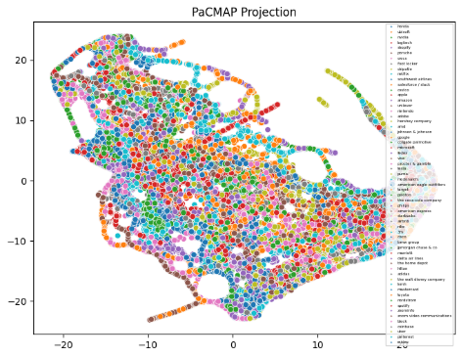 | 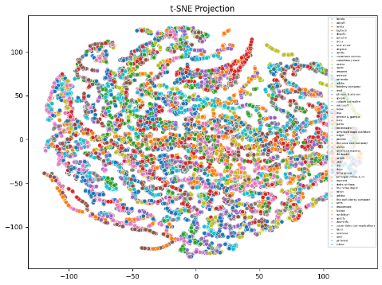
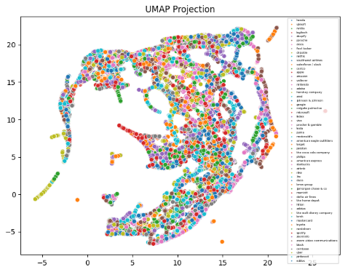 | 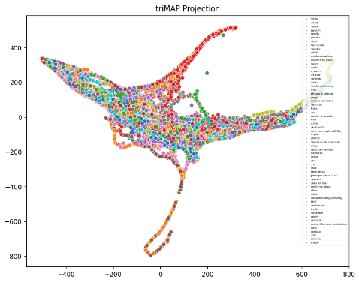
Figure 2: Dimensional Reduction Methods – 2D (Right to Left, PCA, PaCMAP, t-SNE, UMAP, tri-MAP)

